01 CURRENT-STATE ARCHITECTURE — POINTS OF FAILURE
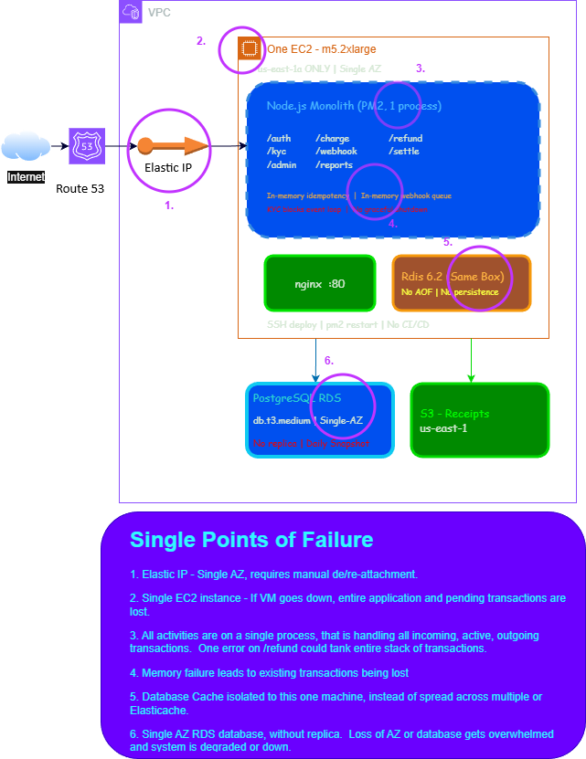

02 TARGET-STATE ARCHITECTURE — BY FRIDAY 16:00 CT

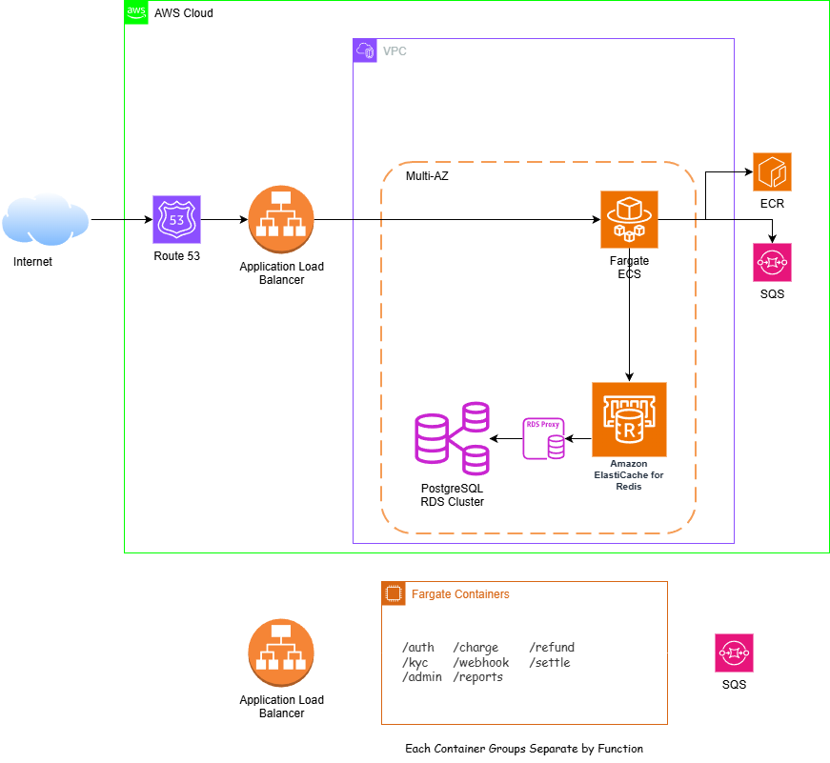

03 SERVICE DECOMPOSITION

Which routes become which service, and why

1. /auth (Card Authorization) -> Application Load Balancer:
a. Route traffic only to healthy targets
b. Scales as incoming traffic changes over time
c. Distributes traffic to multiple Availability Zones
d. Reduce load on application
Source: https://docs.aws.amazon.com/elasticloadbalancing/latest/application/introduction.html
2. In-memory idempotency -> ElastiCache (Node-based cluster due to utilization of Redis 6.2)
a. Supports multi-AZ availability
b. Can scale horizontally or vertically
c. Submillisecond latency
d. Lower-cost service for delivering some database query results
Source: https://docs.aws.amazon.com/AmazonElastiCache/latest/dg/WhatIs.html
3. /webhook (In-memory queue) -> SQS
a. Secure, durable, and available hosted queue
b. Facilitates decoupling of distributed software systems
c. Control who can send messages to and receive messages from an Amazon SQS queue
d. Can scale SQS transparently to handle any load increases or spikes without any provisioning instructions
Source: https://docs.aws.amazon.com/AWSSimpleQueueService/latest/SQSDeveloperGuide/welcome.html
4. /admin -> API Gateway
a. Support canary release deployments for safely rolling out changes
b. Support CloudWatch access logging and execution logging, including the ability to set alarms
c. Integration with AWS WAF for protecting APIs against common web exploits
d. Integration with AWS X-Ray for understanding and triaging performance latencies
Source: https://docs.aws.amazon.com/apigateway/latest/developerguide/welcome.html

04 RUNTIME CHOICE — ECS FARGATE VS EKS

DECISION
ECS Fargate. EKS may be an eventual target for microservice deployment in the future but ECS meets the following needs more effectively:
- Speed and simplicity of implementation
- Tight Integration with other AWS services
- Cost Efficiency

Dimension | ECS Fargate | EKS
Operational overhead | Zero control-plane management. AWS handles scheduling, scaling, patching. One task definition = one deployment unit. | Managed control plane but node groups, add-ons (Load Balancer Controller, EBS CSI, CoreDNS), and cluster upgrades are engineer-owned.
48-hour feasibility | Task Definition + ECS Service + ALB target group = ~2 hours from zero. Well-understood by any AWS-certified architect. | Cluster bootstrapping, IRSA, VPC CNI, and add-on wiring reliably consume 6-10 hours of the budget.
Native AWS integration | First-class: IAM task roles, ALB, CloudWatch Container Insights, Secrets Manager, EFS — zero adapter layer. | Works but requires AWS-specific add-ons and IRSA configuration for each service account.
Monolith fit | Excellent. One container, one service, one task definition. Conceptually matches the problem. | Kubernetes earns its complexity across 10+ independently scheduled workloads. For 3 services it's over-engineered.
Cost (Day 2) | Pay per task-second. No idle EC2 node cost. Predictable for the sizes we need. | $0.10/hr EKS control plane + EC2 node group cost even at idle.
Future microservice path | Good: ECS services model microservices cleanly. Lacks Helm, CRDs, Istio, ArgoCD — limits ecosystem. | Excellent: Kubernetes is the industry standard. Full CNCF ecosystem available.
PCI-DSS scope | Fargate is PCI-DSS Level 1 certified. Fargate eliminates EC2 host OS from PCI scope (AWS owns the host). | EKS worker nodes (EC2) are in scope for PCI DSS controls — requires additional hardening and node isolation.

EKS Migration Trigger
When service decomposition reaches ≥5 independently deployed services and the team needs Helm chart management, Istio service mesh, or KEDA event-driven autoscaling, migrate using the Strangler Fig pattern at the data plane level — stand up EKS in parallel, migrate services one at a time, decommission ECS when the last service is moved. Estimated trigger: Q3 2026.

05 DATA PLANE

Service | Benefits
RDS Multi-AZ Config | AWS automatically provisions and maintains one or more secondary DB instances in a different AZ  Provides data redundancy and failover support  Eliminates I/O freezes  Minimizes latency spikes during system backups  Failover as quickly as 35 seconds
ElastiCache for Redis | Supports Multi-AZ availability  Can scale horizontally or vertically  Supports submillisecond latency  Lower-cost service for delivering some database query results
SQS for Webhooks | Secure, durable, and available hosted queue  Facilitates decoupling of distributed software systems  Control who can send messages to and receive messages from an Amazon SQS queue  Can scale SQS transparently to handle any load increases or spikes without any provisioning instructions

06 CI/CD PIPELINE

How a commit reaches Production:

- Developer commits code changes from their local repo to the GitHub repository
- GitHub Action triggers the build stage
- GitHub’s Open ID Connector (OIDC) uses the tokens to authenticate to AWS and access resources
- GitHub action uploads the deployment artifacts to Amazon S3
- GitHub action invokes CodeDeploy
- CodeDeploy triggers the deployment to Amazon EC2 instances in an Autoscaling group
- CodeDeploy downloads the artifacts from Amazon S3 and deploys to Amazon EC2 instances
- Once complete in the lowest environment (ex. Development Environment), execute test cases to confirm successful tests, then repeat the steps above in higher environments until changes have been deployed and verified in Production

07 HA/DR NUMBERS — RTO, RPO, AND PROOF

Failure Scenario | Today RTO | Today RPO | Target RTO | How We Prove It (Day 2)
Single container crash | ~20 min | 0 (stateless) | < 30s | Harvey terminates a running Fargate task during live load test. Brent narrates ALB health check detecting failure and routing to remaining tasks. Peer reads CloudWatch alarm clearing.
Full AZ failure (us-east-1a) | ~4 hours | up to 24h | RTO < 5 min, RPO < 1 min | Simulate by moving all payment-api tasks in us-east-1a to desired=0 while traffic runs. ALB detects health failures, routes to us-east-1b tasks. RDS promotes Multi-AZ standby automatically.
Bad deploy | ~15 min | 0 | < 60s rollback | Deploy a build with a synthetic bug that triggers a p99 alarm. Show CodeDeploy auto-rollback shifting traffic back to blue. Request log shows zero HTTP 5xx gap.
Database corruption | 4-24 hours | up to 24h | RPO < 5 min | Show PITR in RDS console. Identify restore point 5 minutes prior to current time. Demonstrate restore-to-new-instance process. Show CloudWatch logs confirming last transaction committed before corruption point.
Redis / ElastiCache failure | ~20 min (same host) | Full key loss | RPO < 30s | ElastiCache Multi-AZ: primary failure triggers automatic replica promotion in ~30s. payment-api reconnects on next request. Idempotency keys are re-cacheable from DB if needed.

Proof Methodology
- All chaos events executed with k6 continuously sending /auth requests at 300 TPS. Error rate and p99 recorded in CloudWatch.
- RTO measured from moment of simulated failure to moment CloudWatch shows 0 HTTP 5xx and p99 < 200ms.
- RPO measured by comparing last committed DB transaction timestamp against recovery point timestamp.
- Results logged to a shared runbook doc with screenshots. Available for review.

08 MIGRATION PLAN — ZERO-DOWNTIME CUTOVER (STRANGLER FIG)

09 COST DELTA

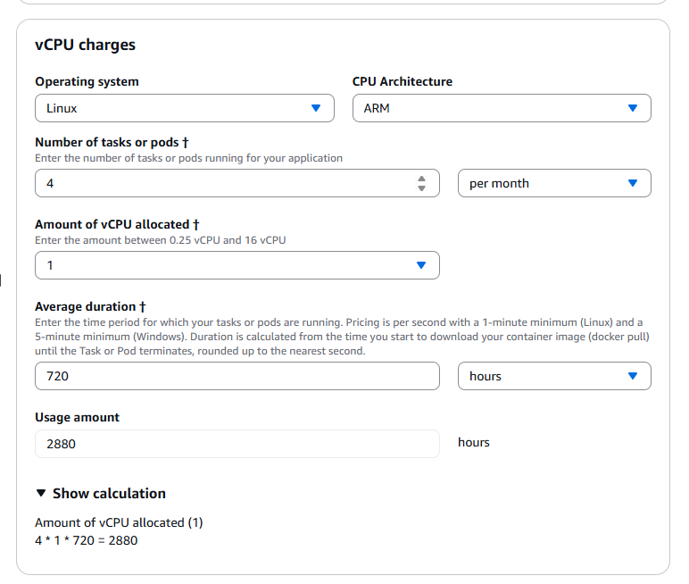

Current spend: ~$640/month (estimated based on single m5.2xlarge + RDS single-AZ). Proposed spend adds HA, redundancy, and managed services. The delta is justified by eliminating the SPOF that puts $22M/month GMV at risk.

Service | Current | Proposed | Delta | Notes
EC2 m5.2xlarge (monolith host) | $280/mo | $0 | -$280 | Terminated after cutover
RDS PostgreSQL (single-AZ, db.t3.medium est.) includes RDS Proxy | $120/mo | $211.25/mo | +$70 | Multi-AZ doubles storage I/O charge; standby replica cost
RDS Read Replica (db.t3.medium, us-east-1b) | $0 | $95/mo | +$95 | Analytics offload; can defer to Q3
ElastiCache Redis (cache.t3.small, 1 primary + 1 replica) | $0 (on-host) | $48/mo | +$48 | Replaces colocated Redis
ECS Fargate — payment-api (3 tasks × 0.5 vCPU × 1 GB, 730h) | $0 | $78/mo | +$78 | ~0.0107/vCPU-h + 0.00117/GB-h
ECS Fargate — kyc-service (2 tasks × 0.5 vCPU × 0.5 GB, 730h) | $0 | $36/mo | +$36 | Can scale to 0 during off-hours
ECS Fargate — webhook-worker (2 tasks × 0.25 vCPU × 0.5 GB, 730h) | $0 | $22/mo | +$22 | Low CPU, high I/O profile
Application Load Balancer | $0 | $22/mo | +$22 | $0.008/LCU-h base + usage
SQS (novapay-webhooks + DLQ) | $0 | ~$2/mo | +$2 | Negligible at current volume
NAT Gateway (2 AZs × $0.045/h) | $0 | $65/mo | +$65 | Required for private subnet egress
CloudWatch / Container Insights | $5/mo | $20/mo | +$15 | Log ingestion + custom metrics
Secrets Manager (5 secrets × $0.40/mo) | $0 | $2/mo | +$2 | DB creds, Redis auth, API keys
TOTAL | ~$640/mo | ~$580/mo | -$60/mo | ~9% lower cost, dramatically higher availability

COST VERDICT
The proposed architecture costs approximately $580/month — slightly less than current spend due to eliminating the m5.2xlarge EC2 instance. The read replica ($95/mo) can be deferred to Q3. Without it, monthly spend is ~$485 — a 24% reduction. The HA story ($22M GMV protected by a $60/month net delta) is a straightforward ROI narrative for Jordan Blake.

10 RISK REGISTER

# | Risk | Likelihood | Impact | Mitigation
1 | Migration cutover causes payment downtime during Phase 2 traffic shift | Medium | Critical | Weighted ALB routing: start at 10%, monitor 10 minutes before increasing. Automated rollback on any CloudWatch alarm breach (HTTP 5xx > 1%). Perform cutover during off-peak hours (2am CT). Monolith EC2 remains warm for 24 hours post-cutover.
2 | Database connection pool exhaustion under ECS scale-out | Medium | High | RDS Proxy deployed in front of the writer endpoint. RDS Proxy multiplexes ECS task connections — 100 tasks sharing 20 DB connections is supported. Monitor RDS Proxy connection count in CloudWatch; alarm at 80% of max_connections.
3 | Webhook-worker duplicate delivery causes merchant double-charges | Medium | High | SQS Standard Queue guarantees at-least-once, not exactly-once. Mitigation: payment-api checks DB status before processing — captured transactions are idempotent on re-delivery. Long-term: migrate to SQS FIFO with content-based deduplication. Document at-least-once semantics in merchant integration guide.
4 | PCI-DSS scope expansion challenge from Jordan Blake | High | Medium | Pre-empt: Fargate removes EC2 host OS from PCI scope (AWS manages the host). VPC private subnets enforce network isolation. RDS encryption in-transit and at-rest. Secrets Manager for credentials. All cardholder data remains in us-east-1 (US-only per any compliance ask). Can produce a brief PCI scoping narrative on request.
5 | 48-hour timeline overrun — demo not ready by 16:00 CT Friday | Medium | Critical | Priority sequencing: P0 items (containerize, ECS deploy, ALB, RDS Multi-AZ, ElastiCache) complete by Thursday 22:00 CT. Friday morning: SQS + webhook-worker. Friday afternoon: load test + chaos demo rehearsal. If SQS is not complete by Friday 12:00: demo webhook resilience using in-memory queue with graceful drain — disclose gap and commit to SQS by Monday.

